SEE CCR TSOs proposal for Redispatching and Countertrading cost sharing methodology in accordance with Article 74 of Commission Regulation (EU) 2015/1222 of 24 July 2015 establishing a guideline on capacity allocation and congestion management
September 2018

All Transmission System Operators of the SEE CCR (ADMIE, ESO EAD, Transelectrica) taking into account the following,

Whereas
- This document is a common proposal developed by all Transmission System Operators of the SEE Capacity Calculation Region (hereafter referred to as “TSOs”), for Redispatching and Countertrading cost sharing (hereafter referred to as “Cost sharing proposal”) in accordance with Article 74 of Commission regulation (EU) 2015/1222 establishing a guideline on Capacity allocation and congestion management (hereafter referred to as the ‘’CACM Regulation.’’).
- According to Article 9 (9) of the CACM Regulation, a timeline for implementation of the proposed Cost Sharing Proposal has to be included. The timeline for monitoring and implementation is presented in Articles 11 and 14 of this document.
- According to Article 9 (9) of the CACM Regulation, the expected impact of the Proposal on the objectives of the CACM Regulation has to be described. The impact is presented below (point 7 of the Whereas).
- The TSOs aim at ensuring consistency with the redispatching and countertrading cost sharing methodologies of other Capacity Calculation Regions in which same bidding zones are concerned whilst acknowledging the specific characteristics of the interconnectors within the SEE Capacity Calculation Region.
- This proposal takes into account the TSOs' proposal for a day-ahead and intraday capacity calculation methodology in accordance with Article 20 of the CACM Regulation and submitted to the NRAs.
- This proposal takes into account the TSOs' proposal for the coordinated Redispatching and Countertrading methodology (hereinafter referred to as the “SEE RD and CT Methodology”) in accordance with Article 35 of the CACM Regulation and submitted to the NRAs of the SEE CCR for approval. The main aim of Countertrading and Redispatching methodology is to maximize cross border capacity over the SEE CCR, while ensuring the grid security.
- The Cost Sharing Proposal contributes to and does not in any way hinder the achievement of the objectives of Article 3 of the CACM Regulation. In particular this Cost Sharing Proposal:
a. Establishes a common process for the Redispatching and Countertrading cost sharing by defining a set of harmonised rules for congestion management and as such serves the objective of promoting effective competition in the generation, trading and supply of electricity in accordance with Article 3(a) of the CACM Regulation;
b. Contributes to the objective of ensuring optimal use of the transmission infrastructure in accordance with Article 3 (b) of the CACM Regulation by using last available inputs based on the best possible forecast of transmission systems and market results at the time of each security analysis, updated in a timely manner, for the detection of Coordinated Redispatching and Countertrading needs
c. Contributes to the objective of ensuring and enhancing the transparency and reliability of information in accordance with Article 3 (f) of CACM Regulation by providing mechanism to verify the needs, monitor, assess the impact and allow improvement of Countertrading in the SEE CCR Region (Article 74 (5) of CACM Regulation).
d. Contributes to the objective of respecting the need for a fair and orderly market and price formation by developing rules within this methodology that ensure a fair distribution of costs and benefits between the involved TSOs.
- According to Article 74 (4) of CACM Regulation, the redispatching and countertrading cost sharing methodology shall at least:
a. determine which costs incurred from using remedial actions are eligible for sharing between the TSOs in accordance with the capacity calculation methodology set out in Articles 20 and 21 of CACM Regulation. This Cost Sharing Proposal provides this information in Article 3 .
b. define which costs incurred from using redispatching or countertrading to guarantee the firmness of cross-zonal capacity are eligible for sharing between the TSOs. This Cost Sharing Proposal provides this information in Articles 5 and 6.
c. set rules for region-wide cost sharing. This Cost Sharing Proposal provides this information in Article 11.
- According to Article 74 (5) of CACM Regulation, the redispatching and countertrading cost sharing methodology shall include:
a. a mechanism to verify the actual need for redispatching or countertrading between the TSOs. This Cost Sharing Proposal provides this element in Articles 11 and 13.
b. an ex post mechanism to monitor the use of remedial actions with costs. This Cost Sharing Proposal provides this element in Articles 10 and 11.
c. a mechanism to assess the impact of the remedial actions, based on operational security and economic criteria. This Cost Sharing Proposal provides this element in Articles 11 and 13.
d. a process allowing improvement of the remedial actions; This Cost Sharing Proposal provides this element in Article 13 .
e. a process allowing monitoring of each capacity calculation region by the competent regulatory authorities. This Cost Sharing Proposal provides this element in Article 11.
- According to Article 74 (6) of CACM Regulation, the redispatching and countertrading cost sharing methodology shall also:
a. provide incentives to manage congestion, including remedial actions and incentives to invest effectively.
The cost sharing arrangements defined in this Cost Sharing Proposal ensure a fair distribution of costs between the TSOs, thus facilitating the use of countertrading and redispatching measures, among other available measures, in order to manage the congestions.
b. be consistent with the responsibilities and liabilities of the TSOs and ensure a fair distribution of costs and benefits between the TSOs.
The cost sharing arrangements defined in this Cost Sharing Proposal are sharing the costs between all TSOs based on a prioritization of different flows.
c. facilitate the efficient long-term development and operation of the pan-European interconnected system and the efficient operation of the pan-European electricity market;
d. facilitate adherence to the general principles of congestion management as set out in Article 16 of Regulation (EC) No 714/2009. Article 16 of Regulation (EC) No 714/2009 states that “The maximum capacity of the interconnections and/or the transmission networks affecting cross-border flows shall be made available to market participants, complying with safety standards of secure network operation”. By allowing the application of the Countertrading and Redispatching methodology, the cost sharing arrangements defined in this Cost Sharing Proposal contribute to the maximization of the cross border capacity over the SEE CCR, while ensuring the grid security. Article 16 of Regulation (EC) No 714/2009 states that “Any revenues resulting from the allocation of interconnection shall be used for guaranteeing the actual availability of the allocated capacity”. The cost sharing arrangements defined in this Cost Sharing Proposal facilitate the allocation of the revenues resulting from the allocation of interconnection to the costs of countertrading and redispatching measures used to guarantee the allocated cross border capacity.
e. allow reasonable financial planning. The cost sharing arrangements defined in this Cost Sharing Proposal are based on elements known by all TSOs at the moment these arrangements are applied.
f. be compatible across the day-ahead and intraday market time-frames. The cost sharing arrangements defined in this Cost Sharing Proposal can be applied in both day-ahead and intraday market time-frames.
g. comply with the principles of transparency and non-discrimination.
The cost sharing arrangements defined in this Cost Sharing Proposal are described in a transparent way and are agreed by all TSOs. Moreover, the cost sharing arrangements defined in this Cost Sharing Proposal are based on elements known by all TSOs at the moment these arrangements are applied.

SUBMIT THE FOLLOWING REDISPATCHING AND COUNTERTRADING COST SHARING METHODOLOGY PROPOSAL TO ALL NATIONAL REGULATORY AUTHORITIES OF THE REGION:

General provisions

Article 1
Subject matter and scope

This Cost Sharing Proposal is the common proposal of all TSOs of the SEE Capacity Calculation Region in accordance with Article 74 of the CACM Regulation.

Article 2
Definitions

1. For the purpose of this proposal, the definitions in Article 2 of the CACM Regulation shall apply.
2. In addition, the following definitions (abbreviations) shall apply:
  - a) ‘Remedial actions (RA)’ means an action, which consist as a set of non-costly or costly remedial measures in order to solve overload on congested element.
  - b) ‘Operational security analysis (OSA)’ means an analysis performed by the relevant RSC to identify if operation of the power system is safe and secure for the analysed period.
  - c) ‘Regional Security Coordinator (RSC)’ means an entity, which is responsible to perform OSA and to coordinate implementation of remedial actions within TSOs of the same CCR and among the relevant CCRs.
  - d) ‘Not Coordinated Action (NCA)’ means any action (PST tap change, topological action, etc..) applied by a TSO without coordinating it with the other TSOs of the CCR.

  - e) Coordinated Redispatching and Countertrading Methodology is the methodology according to article 35 CACM Regulation

  - f) Loop flows means the physical flow on a line where the source and sink are located in the same bidding zone and the line or even part of the tie-line is located in a different bidding zone

  - g) ‘Import/Export flows’ means the physical flow on a line where the source and sink are located in different bidding zones that are adjacent to each other

  - h) ‘Transit flows’ means the physical flow on a line where the source and sink are located in different bidding zones that are not adjacent to each other

  - i) ‘Internal flows’ means the physical flow on a line where the source and sink are located in the same bidding zone and the line or even part of the tie-line is located in the same bidding zone

  - j) ‘Uncoordinated Remedial Action (UCRA)’ means any activation of a cross-border impacting remedial action applied by a TSO which is not coordinated with other TSOs of the CCR.

  - k) ‘Burdening flow’ means a flow identified in the direction that is aggravating a constraint on a critical network element

  - l) ‘Relieving flow’ means a flow identified in the direction that is relieving a constraint on a critical network element

3. In these proposal, including its annexes, unless the context requires otherwise:

- a) the singular indicates the plural and vice versa;
- b) references to one gender include all other genders;
- c) any reference to legislation, regulations, directive, order, instrument, code or any other enactment shall include any modification, extension or re-enactment of it then in force;
- d) any reference to another agreement or document, or any deed or other instrument is to be construed as a reference to that other agreement, or document, deed or other instrument as amended, varied, supplemented, substituted or novated from time to time.

Eligible costs for cost-sharing

Article 3
Cross-border relevance of congestions

The Cost Sharing Methodology covers costs incurred from using redispatching and countertrading measures of cross-border relevance to guarantee the firmness of cross-zonal capacity in accordance with article 74(4)b CACM Regulation and to ensure security of supply, which have been activated by SEE CCR TSOs based on the SEE CCR Coordinated Redispatching and Countertrading Methodology to solve congestions on critical network elements according to the SEE CCR Capacity Calculation Methodology for the Day-Ahead and Intraday timeframes respectively.

Eligible costs for cost-sharing arrangements of this proposal are only those of countertrading or Redispatching measures implemented pursuant to the “SEE RDCT Methodology” to solve a constraint on a critical network element as defined in the SEE CCR DA and ID CC Methodologies in accordance to Article 35 of CACM GL.

Article 4
Real-time operation

The close to real-time period should be understood as the time from the last coordination based on CGM till the operational hour (i.e. CGM are no more updated). In that period each TSO shall use its own state estimation to perform operational security analysis in its observability area. Even within this period, cross-border relevant RA shall be coordinated with concern TSOs to the extent possible.

Each TSO shall abstain from unilateral or uncoordinated RA of cross-border relevance, which could endanger other TSOs grid, without giving the other TSO chances to react to the introduced RA.

In situations, where coordination is not possible (e.g. lack of time), the RAs to be used (e.g. to keep the system in n-1 secure state) should be selected as the most safest one for other grids

If a TSO decides unilaterally to execute costly RAs during this period the TSO shall bear all the cost of the non-coordinated RAs (i.e. requester principle should apply).

Article 5
Countertrading costs

Costs of countertrading shall be the incurred costs to solve a constraint, including imbalancing costs where relevant. Costs of countertrading shall be auditable and transparent.

Article 6
Redispatching costs

Costs of redispatching shall be the incurred costs to solve a constraint. For matter of clarification, costs of redispatching shall include start-up costs and shut-down costs where a generation unit has been started or stopped respectively to solve exclusively a congestion on a CNEC at the time of the decision. Costs of redispatching shall be auditable and transparent. Revenues for TSOs, e.g. received for downward regulation, are treated in the same way like costs. TSOs have to report them in a transparent manner.

All costs and revenues, which belong to one remedial action, will be summed up (netted) in order to get the total costs for each measure. The total costs are the starting point for cost sharing as decribed further below.

Article 7
Description of the activation of costly remedial actions

The activation of the costly RA condisered in this Cost Sharing Methodology is described on the RDCT Methodology to be developped in accordance to the article 35 of CACM GL.

The activation of the costly RA is preceded by the detection and the coordination process.

The detection of a physical congestion is based on the last CGM made avalaible by the relevant RSCs that will propose a (set of) non-costly/costly remedial action(s) in order to solve the congestion. The activation of costly remedial actions can be applied only after all available non-costly remedial actions are exhausted, as it is described in the “SEE RD and CT Methodology”. Both measures are applied exclusively with an aim to ensure firmness of already allocated cross-zonal capacities during DA and ID timeframe in the SEE CCR.

If RD or CT is selected, the coordination process begins amongst the impacted SEE TSOs and the relevant RSCs. By the end of the coordination process, the resources that are activated as RA are known. In function of how the settlement process is done, the total cost of the RA will be calculuated and will be an input for this Cost Sharing Methodology.

Cost-sharing methodology

Article 8
Flow decomposition methodology

The flow decomposition methodology will be used, detailed description of the methodology can be found in the explanatory note.

The flows of a CNE are mainly:

- Loop flows
- Import/export flows and transit flows due to exchanges at borders not belonging to the CCR.
- Internal flows

In order not to discriminate between internal and external flows, the internal flows split additionally into a share that is being used in order to defined a minimum margin of the line for cross border exchanges and a share that is being used for the remaining capacity of the line accepted for internal trades.

Regarding import/export flows, a distinction is necessary between TSOs within the CCR and flows originating from TSOs outside the CCR, because costs of RAs could not be allocated with a causation principle to those TSOs.

Sources (exporters) or sinks (importers) are both referred to as origins of flows. Once all partial flows have been identified, they shall be used to define the sharing keys which shall be primarily be proportional to the aggravating impact of the flows caused by the bidding zones that TSO belongs to. Aggravating impact of flows caused by the bidding zone not belonging to a CCR would be socialized between the TSOs of the CCR.
The FLD method is able to correctly identify the contributions of the various flow types in the European transmission network, and:

- It obeys the commonly accepted proportional sharing principle
- It can be applied on any network model
- It is independent of slack bus location and GSK
- Its results are complaint with the physical properties of the network
- It identifies also relieving and burdening flows

Article 9
Causation principle

All costs that are eligible for cost sharing shall be borne according to the causation principle. In order to identify the causer(s) of congestions, the flow decomposition methodology shall be applied, which decomposes the total flow on congested network element into different flow types. For each flow type, also the source and the sink area are identified as a result of the decomposition on a bidding zone level, where a certain flow starts or ends.
Basis for the application of the causation principle is the flow decomposition methodology as described in the relevant explanatory note.

Only critical network elements which are relevant for the cost sharing with cross border relevance will be considered. Cost sharing shall only be applied on costly Remedial Actions with Cross-border relevance as defined in the RDCT Methodology.

Mapping of costs to critical network elements

The costs of the redispatch measures with cross border relevance which are eligible for cost sharing are a necessary input for the causation principle.

The total costs (sum of costs eligible for cost sharing) will be split up per relevant critical network element. This is called: Mapping of cost per critical network element.

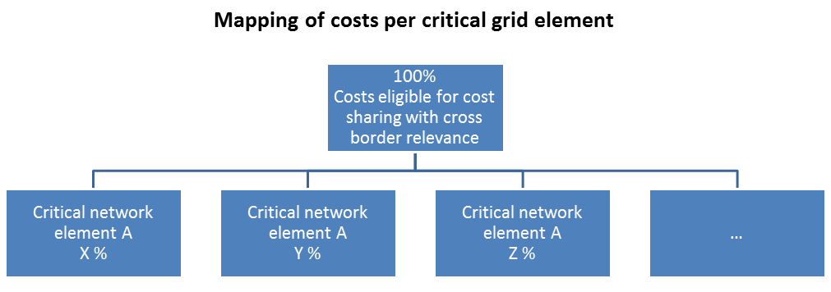

Figure 1

Flows on each critical network element shall be decomposed using the flow decomposition method The decomposed flows per critical network element (result of the flow decomposition) will be assigned to the flows relevant for cost sharing. In other words, based on the results of the flow decomposition the relevant flows for cost sharing with cross border relevance will be identified. In addition, flows can also be split in order to give priority only to a certain share of a flow type (e.g. internal flows below a certain threshold).

Causation principles based on prioritization of flows

In case an overload above the technical admissible limit on a CNE is detected, RAs are identified to reduce the loading of this line. At certain point in time, those RAs will have to be activated. The related costs of these RAs need to be covered by the causing TSOs.

The causers of those flows above the technical limits of the CNE have to share the cost of the RAs in proportion to their share of the MW above the limit.

In general, the costs of the activated RA can be distributed to causers of the different flows according to the following prioritization principle, by starting from the total loading of the CNE and going down to the technical limit:

- burdening loop flows
- If the CNE still is overloaded after the penalized loop flows, internal flows that hinder guaranteeing a minimum market exchange shall be penalized in second place to avoid a discrimination of bids outside the bidding zone. This could be realized by introducing a fixed percentage of the internal flow of the line (freeing up capacity on internal CNE for allowing external exchange). The fixed percentage of 20% of the limit of the internal line will be applied.
- In case the flow on a line still is above the technical limit after cutting loop flows and internal flows for guaranteeing a minimum exchange all other import/export and transit flows shall be penalized before penalizing the remaining internal flows.
Causers of flows above the technical limits of the CNE have to share the cost of the RAs in proportion to their share of the MW above the limit.

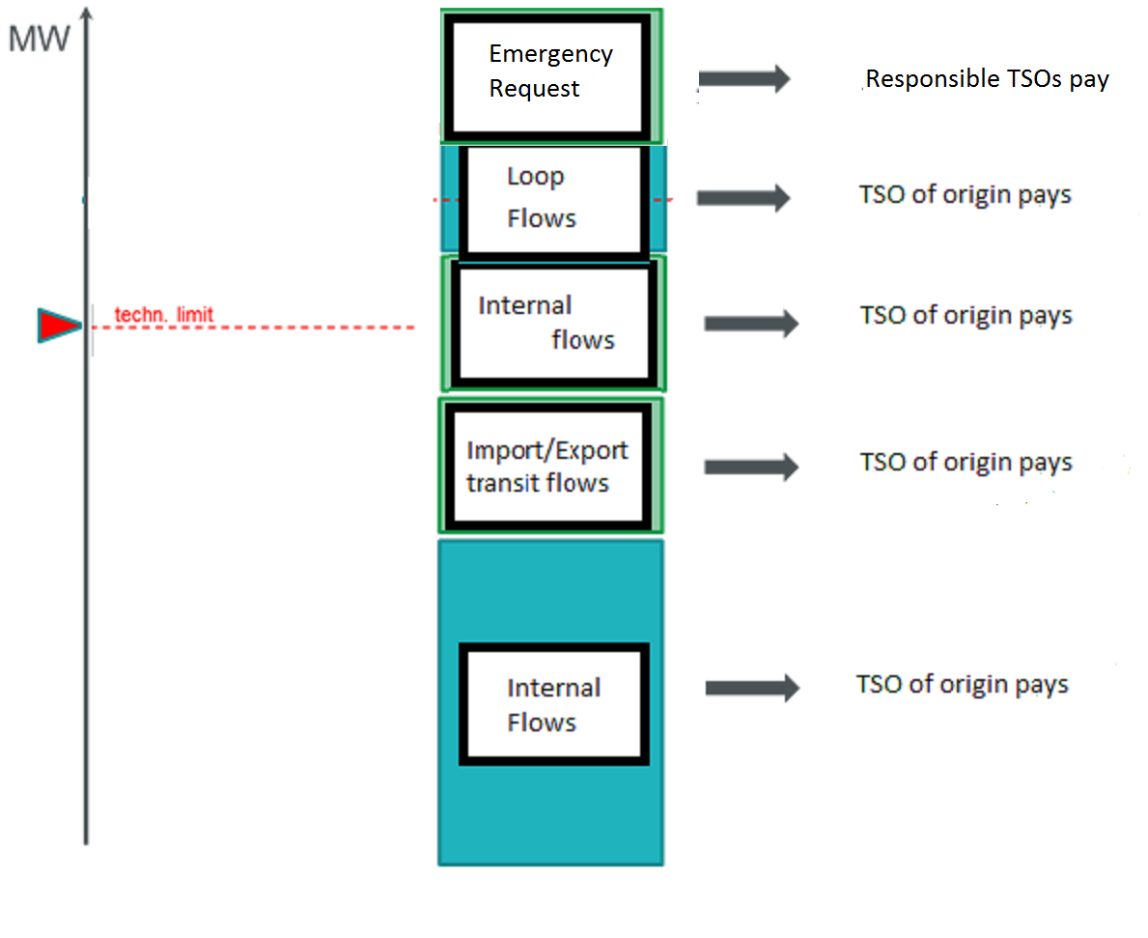

Figure 2 Causation principles based on prioritization of flows

In more detail, the proposed order of priority in cost sharing should be as follows:
- There might be cases where a TSO faces a critical situation (e.g system adequacy challenges) without being able to solve it itself. With an emergency request the concerned TSO can ask neighboring TSOs for their support to increase import capacity. Such increase can lead to overloads on internal or external network elements, which need to be relieved by costly remedial actions. Emergency Requests should be on top. That is outside of normal coordinated process and may happen only in very rare cases. The responsible TSOs pay, i.e the requesters for such emergencies should cover the resulting costs. This case is exceptional and not covered by the generic cost sharing principles.
- Loopflows (ACER recommentation) should also be on top, since it is an externality in zonal process.TSOs of origin pays, i.e the one where loopflows come from. In case the loopflows come from TSOs outside the SEE CCR the socialization principle shall apply.
- If after considering the above the problem still remains, then some share of costs necessary to ensure a margin of internal flows should be applied, so an amount of flows should also be covered by Internal Flows. A minimum remaining available margin (RAM) in flow based approach is used in order to be guaranteed by TSOs on internal CNEs to allow for external exchanges by the market (different kind of solutions are possible to guarantee capacities on internal lines for external exchanges). A similar kind of margin of 20% of the limit of the internal line should be used at the current methodology, bearing in mind the application of CNTC methodology in SEE CCR. In order to achieve a minimum margin (needed to assure the external exchanges), costly RAs might be necessary. TSOs shall be individually responsible for making available a minimum margin by reducing the internal loading on the relevant CNE below the predefined threshold.
- Import/Export flows and transit flows follow where the TSO of origin will pay. That means the contribution of each TSO will be identified again by using the FLD method. Again just like in the case with loopflows, in case transits come from TSOs outside the SEE CCR the socialization principle shall apply.

If after considering all these kinds is still unable to ensure security, then some share of costs necessary to ensure this should also be covered by Internal Flows.

Article 10
Principles for sharing keys calculation

- Non-coordinated actions with RSC
In general all the TSOs within the SEE CCR commit themselves to coordinate between each other when planning and activating remedial actions in an enduring coordination process which goes from capacity calculation, through operational planning, till real time. It is therefore taken as a basic assumption, that TSOs shall act by respecting what was agreed in the previous phases of this coordination process and by following the coordination principles.
Thus, each TSO breaching the above-mentioned coordination process shall bear responsibility for covering the possible additional costs which may arise.
Even close to real-time, cross-border relevant remedial action shall be coordinated (Article 74 (1) SO regulation). Each TSO shall abstain from unilateral or uncoordinated redispatching and countertrading measures of cross-border relevance (Article 35 (4) CACM regulation). The coordination for bilateral/multilateral restoring remedial actions is made between two or more affected TSOs in real time, with possible support of RSCs.
Following principles can be applied depending on TSO approach with the support of RSC :
1. Cost sharing principle in case of coordinated actions according to RSC advice.
In case of coordinated measures, the costs related to remedial actions will be shared according to cost sharing arrangements defined in RD&CT CSP methodology.

2. Cost sharing principle in case of uncoordinated actions deviating from RSC advice.
If TSO decides unilaterally to execute costly remedial actions, the TSO shall bear the additional costs of the uncoordinated remedial action, over costs estimated according to RSC advice.

- Socialization principle

The FLD methodology allows to identify the causer of the congestion (the contribution of each TSO to the congested element), however, not all TSOs can be considered in the settlement process, but only the ones that are members of the SEE CCR. The cost related to the TSOs outside the SEE CCR has to be socialized.

Different principles for the socialization of such costs have been identified:
- based on equal burden principle
- based on number of consumers
- proportional to congestion income/NTCs

Based on the fact that the RO-BG-GR connection is a single root connection with basically a very large of interconnections surround it, the loop flows impact is very high. SEE TSOs consider that the equal burden share represents a good and justified approach since it can be used in order to avoid conflicts among TSOs for a physical network distribution in which they are not responsible.
The external costs are shared equally between the SEE CCR TSOs.

- Prioritization principle
The power flow decomposition methodologies allow to distinguish the kind of flow on the congested element: internal flow, loop flows, export/import flow and transit flow
The prioritization of flows aims at defining a prioritization approach for allocating the costs to the different types of flows.

Two different approaches have been identified to calculate the sharing keys in relation to the different kind of flows:

- Proportional: different flow types are equally considered.
- Prioritization: hierarchical approach, which use a strict order of the different flow types (e.g. loop and internal flows first, exchange flows afterwards) and punish them as a priority list. Different thresholds (TH) for different type of flows could be introduced. For instance, loop flow TH=10% means that only the loop flows that exceed the 10% of the capacity of the congested element are considered on the calculation of the sharing keys. For the SEE CCR in line with ACER and ENTSO-e recommendations, the prioritization is used with the TH=0 % for loop flows.

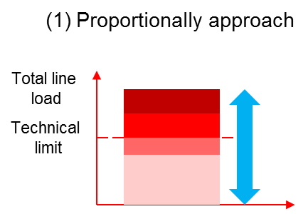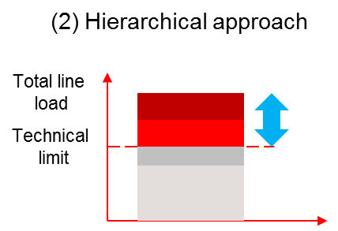

Figure 3

Article 11
Monitoring

For every activation of a remedial action, regardless if countertrading or redispatching is applied, a set of data shall be stored in a central database. The documentation shall be such that it allows for a yearly review for improvement.

The following process steps shall be documented on the central database for each activation of a remedial action:

a) the security violation;

b) the grid model used for the decision for the remedial action, i.e. the grid model that shows the overload;

c) the resources selected by the resource selection process ;

d) the cost of the selected resources given as an input to the resource selection process;

e) the final cost of the selected resources used for settlement;

f) the grid model containing the implementation of the remedial action, i.e. the grid model that shows the effectiveness of the remedial action;

Upon request, TSOs shall provide copies of the credit or debit notes between generators and TSOs. In case of confidentiality issues, the responsible TSO undertakes its best effort to provide the information in an alternative manner.

Article 12

Regular Reporting to NRAs

TSOs will report on a regulary basis to NRAs the relevant information according the requirements of the article 74 of the CACM guideline and according the applicables provisions of the transparency guidelines.

Following information on costs will be reported to NRAs on a yearly basis:
- Total redispatching and countertrading costs eligible for cost sharing per TSO/Country
- Redispatch and countertrading costs according flow type Import/Export; Loop flows; Internal flows and Transit flows per TSO/Country
- list all activations of remedial actions including the security violation, the activated resources and the associated costs;

Article 13

Yearly review for improvement

As required per article 74.5.d of the CACM GL, a process allowing improvement of the remedial actions has to be developped;
Based on the monitoring, TSOs will review the cost sharing process in order to identify potential improvements.

The review shall consist of:

a) an assessment of the effectiveness of the activated remedial actions in terms of volume and cost;
b) an assessment of the proper functioning of the general process with a focus on:

i. deadlines regarding the delivery of data and information;
ii. deadlines regarding the settlement process;
iii. quality of cost estimations;

c) an assessment of the cost-sharing methodology against the criteria mentioned in Art. 74 (6) of CACM Regulation

Article 14

Implementation

The TSOs of SEE CCR shall publish the methodology for cost-sharing of redispatching and countertrading without undue delay after relevant national regulatory authorities have approved the proposed methodology or a decision has been taken by the Agency for the Cooperation of Energy Regulators in accordance with Article 9 (10), Articles 9 (11) and 9 (12) of the CACM Regulation.

The implementation of this methodology for redispatching and countertrading cost-sharing is subject to:

a) Regulatory approval of this Redispatching and Countertrading Cost Sharing Methodology in accordance with Article 9 of the CACM Regulation;
b) Regulatory approval of Common Coordinated Capacity Calculation Methodology required by Article 20 of the CACM Regulation and its implementation;
c) Regulatory approval of the RD and CT Methodology required by Article 35 of the CACM Regulation and its implementation

Article 15

Language

The reference language for this SEE RDCT Cost Sharing Proposal shall be English. For the avoidance of doubt, where TSOs need to translate this into their national language(s), in the event of inconsistencies between the English version published by TSOs in accordance with Article 9 (14) of the CACM Regulation and any version in another language the relevant TSOs shall, in accordance with national legislation, provide the relevant national regulatory authorities with an updated translation of the SEE RDCT Cost Sharing Proposal.

